

Program: ESE 4009_1

# Group# 5

|  |  |  |
| --- | --- | --- |
| Student Name | Student ID | Signature* |
| Mohammed Abdul Muqeeth | C0751945 | MAM |
| Gurman Singh | C0753359 | GS |
| Soumya Thazhathu Panchickal | C0753009 | STP |

*\*By signing above you attest that you have contributed to this submission and confirm that all work you have contributed to this submission is your own work. Any suspicion of copying or plagiarism in this work will result in an investigation of Academic Misconduct and may result in a “0” on the work, an “F” in the course, or possibly more severe penalties.*

**Project Proposal**

**Project Title:**

Gesture Keyboard - Type letters by moving in the air with Machine Learning using Beaglebone Black

**Description of the latest similar system:**

Latest similar system designs a gesture keyboard in which letters are typed in air, that are displayed in PC/laptop. The components used are Arduino board, Bluetooth module, Gyroscope and PC/laptop. The machine learning algorithm "Supervised learning" is used with some predictions along with designed project to detect the alphabet. The whole project or design is controlled by Arduino microcontroller. The project's main aim is to detect the letters by hand in air should be recognized and displayed on the PC/laptop. The gyroscope is attached to hand, so when letters are written in air, through Bluetooth module, the data is transferred to the laptop where they are displayed.

**Limitations of the latest similar system:**

* Very Limited Processing Power available.
* Arduino is a very low power microcontroller.
* External Bluetooth makes it bulky.
* Less Accuracy due to more physical connections.
* No Pause system to stop sending data when needed.
* No IoT aspect.

**Solution 1:**

**Block Diagram**

IoT cloud

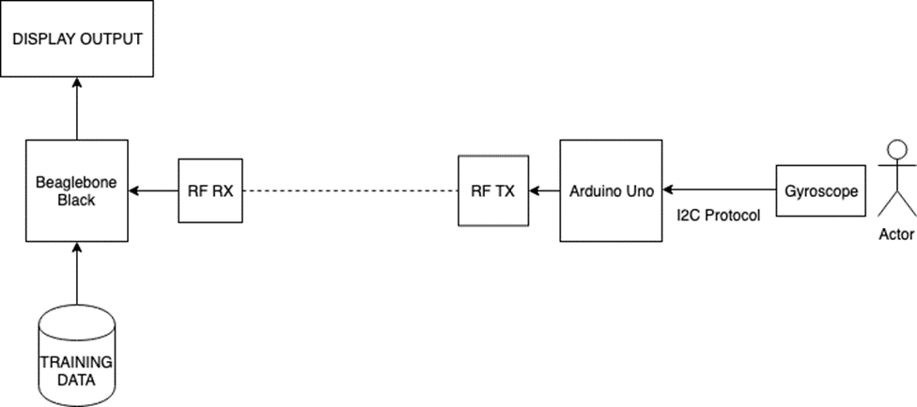

* **Features**
* **Use of various peripherals such as touch screens, cameras, microphones and speakers, GPIOs, timers, GPS modules, Bluetooth, WiFi, and ADC/DACs?**

Gryscope + Accelerometer, Bluetooth Module, HDMI Display, Power Supply , WiFi module.

* **Use of I2C, SPI, RS232/RS-485, IrDA infrared, JTAG, USB, Bluetooth, IEEE 802.11 WiFi, IEEE 802.3 Ethernet, CAN and GPS protocols and systems?**

Bluetooth Communication, I2C, HDMI, USB

* **Use of preemptive versus cooperative scheduler operation; tick rate and time slicing; critical code; fixed, dynamic and hybrid task priority allocation; application-specific considerations; power management tactics; semaphores, mutexes and queues; debugging strategies; performance estimation?**
* A real-time performance is expected as processing will be done by Beaglebone Black.
* I2C Protocol used for low noise data transmission from sensor.
* Use of Machine Learning Algorithm for better accuracy.
* **Hardware and Software Requirement**

**Hardware Requirement:**

Beaglebone Black

Bluetooth Module

WiFi module

5V Power Adapter

USB Cables

HDMI Display

Arduino UNO

USB Keyboard

RF 315/433 MHZ transmitter-Receiver

**Software Requirement:**

Python programming language for Machine learning

Easy EDA for hardware simulation.

C programming

Adafruit IO for IoT cloud services

* **References:**
* Vanditgajjar,VirajmavaniandAyishagurnani .“Hand gesture real time paint tool-box” using machine learning. Conference on power,control,signals and instrumentation engineering(ICPCSI-2017).
* Martina Eckert, Marcos Lopez, Carlos Lazaro, JunanMeneses and Jose F.Martinez Ortega."Mokey-A Motion Based Keyboard Interpreter" conference on 2015.
* MarkusModzelewski and Esteban BaytroKaiser. "Hand Gesture Recognition Interface For Visually Impaired And Blind People", International Conference on Computer and Information Science(2012).

**Solution 2:**

* **Block Diagram**

IoT cloud

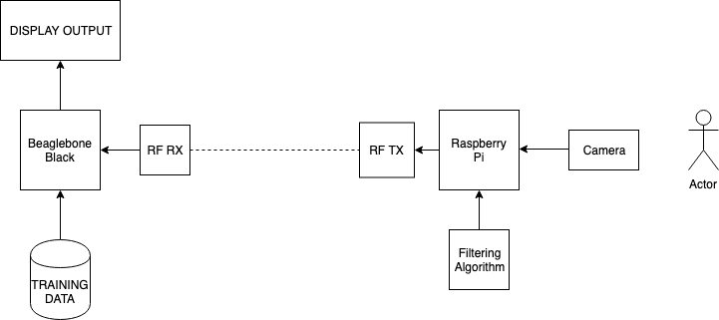

* **Features**
* **Use of various peripherals such as touch screens, cameras, microphones and speakers, GPIOs, timers, GPS modules, Bluetooth, WiFi, and ADC/DACs?**

Raspberry Pi Camera, Power Supply, HDMI Display.

* **Use of I2C, SPI, RS232/RS-485, IrDA infrared, JTAG, USB, Bluetooth, IEEE 802.11 WiFi, IEEE 802.3 Ethernet, CAN and GPS protocols and systems?**

On board Bluetooth Communication, HDMI, USB, on-board WiFi.

* **Use of preemptive versus cooperative scheduler operation; tick rate and time slicing; critical code; fixed, dynamic and hybrid task priority allocation; application-specific considerations; power management tactics; semaphores, mutexes and queues; debugging strategies; performance estimation?**

A real-time performance is expected as processing work is being shared by Beaglebone Black and Raspberry Pi.

Camera is used for tracking movement, hence no need of physically connecting any sensor to user.

Use of Image Processing and Machine Learning Algorithm for better accuracy.

* **Hardware and Software Requirement**

**Hardware Requirement:**

RF 315/433 MHZ transmitter-Receiver

Beagle bone Black

5V Power Adapter

USB Cables

HDMI Display

Raspberry Pi

Raspberry Pi Camera

USB Keyboard

**Software Requirement:**

C Programming

Machine Learning

Python language for machine learning

Easy EDA for hardware simulation

Adafruit IO for IoT cloud

* **References:**
* Cost-effective hand gesture computer control interface7th IEEE International Conference on Cognitive Infocommunications (CogInfoCom 2016) • October 16- 18, 2016 • Wrocław, Poland.
* Gesture Control of Mobile Robot Based ArduinoMicrocontroller-8th International Conference on Modelling, Identification and Control (ICMIC-2016), Algiers, Algeria- November 15-17, 2016.
* Matthias Rehm, Nikolaus Bee, Elisabeth André, Wave Like an Egyptian - Accelerometer Based Gesture Recognition for Culture Specific Interactions, British Computer Society, 2007.
* Accelerometer based Wireless Air Mouse using Arduino Micro-controller Board - Proceedings of 2015 Global Conference on Communication Technologies (GCCT 2015).

**Final Solution (after presentation):**

*As a final solution, we are implementing the above discussed solution 1 but with minor changes. We are replacing PC/Laptop with LCD Monitor. By using the WIFI module, we are storing the letters on the ADAFRUIT IO cloud services.*

* **Block Diagram**



IoT cloud

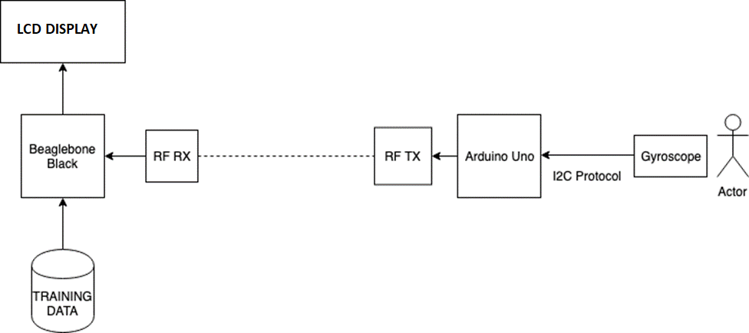

HC-12

HC-12



Voltage Regulator

WIFI module

Li-Ion Battery

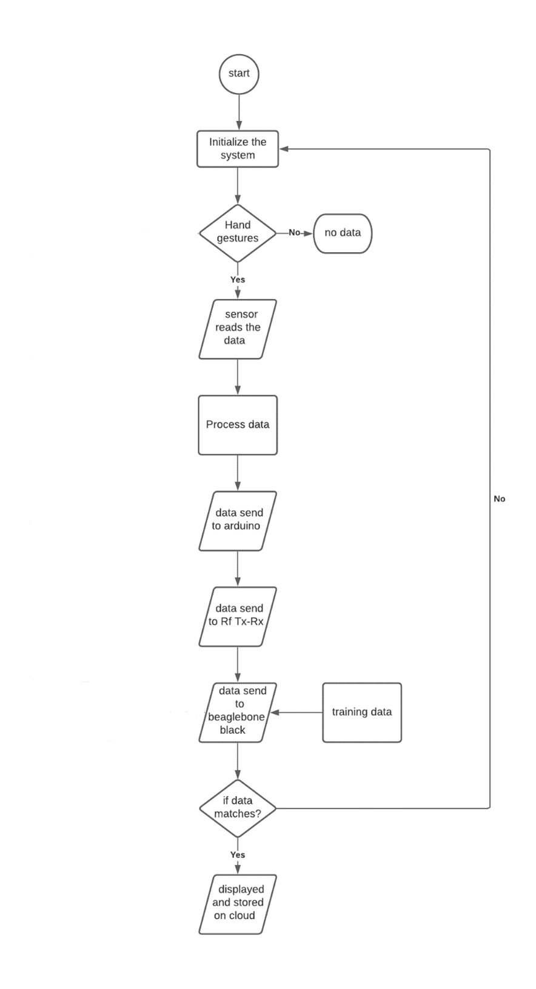

* **Features**
* **Use of various peripherals such as touch screens, cameras, microphones and speakers, GPIOs, timers, GPS modules, Bluetooth, WiFi, and ADC/DACs?**

Gyroscope + Accelerometer, Wi-Fi module, LCD Display, Power Supply, HC-12 tranceiver.

* + Gyroscope is used as the sensor being attached to hand which reads the motion pattern.
  + Arduino Uno digital input/output pin is directly connected to the data pin of the HC-12 transmitter.
  + HC-12 data pins are used to interface with beaglebone black and Arduino UNO.
  + Lithium ion battery can be used for power supply
  + ESP8266 Wi-Fi module is being used to transmit the data to cloud.
  + USB protocol is used to interface beaglebone black to Wi-Fi module
* **Use of I2C, SPI, RS232/RS-485, IrDA infrared, JTAG, USB, Bluetooth, IEEE 802.11 Wi-Fi, IEEE 802.3 Ethernet, CAN and GPS protocols and systems?**
  + ESP8266 is an IEEE 802.11 Wi-Fi is used to transmit data to cloud and USB protocol are used to interface this.
  + We are using I2C communication protocol to interface LCD Display.
  + Gyroscope is interfaced to Arduino using I2C protocol
* **Use of preemptive versus cooperative scheduler operation; tick rate and time slicing; critical code; fixed, dynamic and hybrid task priority allocation; application-specific considerations; power management tactics; semaphores, mutexes and queues; debugging strategies; performance estimation?**
* A real-time performance is expected as processing will be done by Beaglebone Black.
* I2C Protocol used for low noise data transmission from sensor.
* Use of Machine Learning Algorithm for better accuracy.
* **Hardware and Software Requirement**

**Hardware Requirement:**

Beaglebone Black

Gyroscope sensor

Wi-Fi module

Lithium ion battery for power supply

LCD Display

Arduino UNO

HC-12 transmitter-Receiver

**Software Requirement:**

Python programming language for Machine learning

PyCharm for Algo Training

Easy EDA software for hardware simulation and schematic capture.

C programming: Eclipse

Adafruit IO for IoT cloud services

**Hardware tools:**

**Beaglebone Black:**

The Beaglebone is a low-power open-source single-board computer produced by Texas Instruments in association with Digi-Key and Newark element14. The operating voltage is 5V.

**Gyroscope sensor – MPU6050**

The MPU-6050 devices combine a 3-axis gyroscope and a 3-axis accelerometer on the same silicon die, together with an onboard Digital Motion Processor™ (DMP™), which processes complex 6-axis Motion Fusion algorithms. The devices are offered in a 4 mm x 4 mm x 0.9 mm QFN package.

**Wi-Fi module – USB Adapter**

A USB Wi-Fi adapter overrides the computer's built-in wireless functionality, giving you a faster, more reliable connection to your available network signals through the USB port instead. Since most computers have at least one USB port, you’ll typically be able to use it on both laptops and desktops. Plus, the plug-and-play convenience means you can remove the device when it's not needed to use in another computer.

**Lithium ion battery – 3 cell li-ion battery**

A lithium-ion battery or Li-ion battery is a type of rechargeable battery. Lithium-ion batteries are commonly used for portable electronics and electric vehicles.

**LCD Display – 16x2 LCD i2c based**

An LCD (Liquid Crystal Display) screen is an electronic display module. A 16x2 LCD display is very basic module and is very commonly used in various devices and circuits. A 16x2 LCD means it can display 16 characters per line and there are 2 such lines.

**Arduino UNO – Arduino Uno**

The Arduino Uno is an open-source microcontroller board based on the Microchip ATmega328P microcontroller and developed by Arduino.cc. The board is equipped with sets of digital and analog input/output pins that may be interfaced to various expansion boards and other circuits.

**HC-12 Tranceiver**

The HC-12 is a half-duplex wireless serial communication module with 100 channels in the 433.4-473.0 MHz range that is capable of transmitting up to 1 km.

**Voltage Regulator – LM2596 Module**

LM2596 Power Supply is a step-down switching regulator, capable of driving a 3-A load with excellent line and load regulation.

**Digital Multimeter**

Digital Multimeter is an instrument used to measure the electrical values which include but not limited to voltage, current and resistance. The image below illustrates the overview of Digital multimeter.

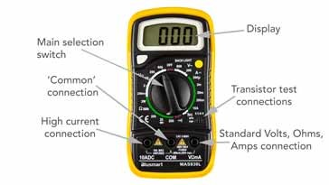

**Power supply**

Power is an important aspect of all embedded systems. Nothing works without electric power. Depending upon the type of applications, several options for power are available. In this project, we will be using a 3-cell Li-Ion Battery as a power supply.

An embedded system consists of many different components that can operate from a wide range of power supply. But some components, such as Analog-to-Digital Converters (ADCs), require a constant voltage supply to provide an accurate output because they need a reference voltage for converting the analog signal to digital count. A device, known as voltage regulator, is used for this purpose. Its job is to convert a range of input DC voltages to a constant output voltage. Besides, a voltage regulator also minimizes the power supply noise and provide a sort of protection for the embedded system from any possible damages due to fluctuating input voltages. Hence, we are using voltage regulators to provide constant power supply to our development boards.

**Soldering iron**

A soldering iron is a hand tool used to heat solder, usually from an electrical supply at high temperatures above the melting point of the metal alloy. This allows for the solder to flow between the workpieces needing to be joined.

**PCB Design**

Printed circuit board (PCB) design brings your electronic circuits to life in the physical form. Using layout software, the PCB design process combines component placement and routing to define electrical connectivity on a manufactured circuit board.

**Bread Board, pliers etc.**

A breadboard is a solderless device for temporary prototype with electronics and test circuit designs. Most electronic components in electronic circuits can be interconnected by inserting their leads or terminals into the holes and then making connections through wires where appropriate. Pliers can be used for twisting or cutting wires, when necessary.

**Jumper wires or connecting wires**

Jumper wires are simply wiring that have connector pins at each end, allowing them to be used to connect two points to each other without soldering. Jumper wires are typically used with [breadboards](https://blog.sparkfuneducation.com/what-is-a-breadboard) and other prototyping tools in order to make it easy to change a circuit as needed

**Software tools:**

**ECLIPSE**

Eclipse is an integrated development environment used in computer programming. It contains a base workspace and an extensible plug-in system for customizing the environment.

**SSH**

Secure Shell is a cryptographic network protocol for operating network services securely over an unsecured network. Typical applications include remote command-line, login, and remote command execution, but any network service can be secured with SSH.

**USB**

This protocol is used to interface beaglebone black with Wi-Fi. This protocol is bandwidth efficient and uses less battery power. Hence, used in many IoT projects

**GCC**

The GNU Compiler Collection is a compiler system produced by the GNU Project supporting various programming languages. GCC is a key component of the GNU toolchain and the standard compiler for most projects related to GNU and Linux, including the Linux kernel.

**ARDUINO IDE**  
  
The Arduino Integrated Development Environment is a cross-platform application that is written in functions from C and C++. It is used to write and upload programs to Arduino compatible boards, but also, with the help of third-party cores, other vendor development boards.

**ADAFRUIT IO**

Adafruit.io is a cloud service without the management. It provides the ability to **store data and interact with the microcontroller**, all over Wi-Fi. This allows you to check on your device wherever you have an internet connection.

* **Cost estimation**

|  |  |  |
| --- | --- | --- |
| **Component** | **Cost(cad)** | **Website** |
| Gyroscope sensor MPU6050 | 11.43 | https://www.digikey.ca/en/products/detail/tdk-invensense/MPU-6050/4038009 |
| Arduino UNO | 28 | https://www.creatroninc.com/product/arduino-uno-rev3/ |
| HC-12 Module | 31.57 |  |
| LM2596 voltage regulator | 7.99 | https://www.digikey.ca/en/products/detail/texas-instruments/LM2596T-12-NOPB/363706 |
| Beaglebone black | 62.22 | https://www.digikey.ca/en/products/detail/beagleboard-by-seeed-studio/102110420/12719590 |
| 16x2 LCD display | 12.10 | https://www.amazon.ca/RoboJax-LCD1602-Screen-Character-Display/dp/B07C5NCY57/ref=sr_1_1?dchild=1 |
| 3 cell Li-ion battery | 95.69 | https://www.digikey.ca/en/products/detail/energizer-battery-company/NH35BP-2F4/1040754 |
| ESP8266 Wi-Fi module | 15 | https://www.creatroninc.com/product/esp8266-wifi-development-board-2/ |
| PCB Design | 50 |  |
| Soldering Gun and digital multimeter | 30 | www.amazon.ca |
| Bread Board | 7.80 | https://www.creatroninc.com/product/full-size-breadboard-white/ |
| Jumper wires | 4.70 | https://www.creatroninc.com/product/3-f-f-jumper-wire-10-pack/ |

**Total estimated cost: 402.85 cad**

* **Milestones (Deliverables and Time Schedule)**

|  |  |  |  |
| --- | --- | --- | --- |
| **Task** | **Start date** | **End date** | **Person-in-charge** |
| Project proposal | September 13,2020 | October 9,2020 |  |
| Component selection and ordering | October 10,2020 | October 12,2020 | Soumya |
| Testing hardware components | October 20,2020 | October 24,2020 | Gurman |
| Circuit design | October 25,2020 | October 29,2020 | Mohammed |
| Interfacing sensor to Arduino, design machine learning algorithm,related coding | October30,2020 | November 11,2020 | Soumya |
| Interfacing Wi-Fi module with beaglebone black and related coding | November 12,2020 | November 17,2020 | Gurman |
| Interfacing tx-rx with beaglebone black and Arduino | November 18,2020 | November 23,2020 | Mohammed |
| Interfacing beaglebone black and lcd display | November 24,2020 | November 29,2020 | Soumya |
| Design of cloud infrastructure and testing | Nov30,2020 | December5,2020 | Gurman |
| PCB design | December 6,2020 | December 11,2020 | Mohammed |
| Final presentation | December 12,2020 | December 15,2020 | Group work |
| Final project report | December 15,2020 |  | Group work |

**Design standards of our project**

**Performance:** This project is designed to ensure high performance and accuracy with low power dissipation as we aren't using additional modules such as GPS and GSM which dissipates more power.

**Power:** Our project is indeed battery operated.

**Deadline oriented:**  As the Beaglebone Black is being used as the Master device, the project is expected to have real time response.

**Safety and security standards:** Nobody except those who have the login details of Adafruit IO can view the data being stored on the cloud.

**Maintenance:**  It is easy to maintain and avoid/handle the failure of system as we only have one sensor involved.

**Cost:** This is a cost-effective project under 500 cad.

**Communication standards of Embedded systems**

**I2C protocol:** To interface gyroscope sensor with Arduino Uno and lcd display with beaglebone black. I2C is a serial protocol for two-wire interface to connect low-speed devices like microcontrollers, EEPROMs, A/D and D/A converters, I/O interfaces and other similar peripherals in embedded systems. It was invented by Philips. I2C bus is popular because it is simple to use, there can be more than one master, only upper bus speed is defined and only two wires with pull-up resistors are needed to connect almost unlimited number of I2C devices. I2C can use even slower microcontrollers with general-purpose I/O pins since they only need to generate correct start and stop conditions in addition to functions for reading and writing a byte.

**Advantages of I2C protocol:** More than one master device can be used in a circuit. I2C requires only two wires of communication. Hence it minimizes the interconnection between ICs.

**Disdavantages:** The hardware complexity might increase.

**MQTT:** This protocol is used for cloud storage or to beaglebone black with Adafruit IOT. MQTT is an OASIS standard messaging protocol for the Internet of Things (IoT). It is designed as an extremely lightweight publish/subscribe messaging transport that is ideal for connecting remote devices with a small code footprint and minimal network bandwidth. MQTT today is used in a wide variety of industries, such as automotive, manufacturing, telecommunications, oil and gas, etc. MQTT allows for messaging between device to cloud and cloud to device. This makes for easy broadcasting messages to groups of things. MQTT can scale to connect with millions of IoT devices.

**Advantages of MQTT**: It use the packet of low size hence it can be use low bandwidth also.

**Disadvantages of MQTT**: It does not support advance features such as flow control.

* **ESP8266:** ESP8266 is an IEEE 802.11 Wi-Fi is used to transmit data to cloud and MQTT protocol is used to interface this. It is a WiFi microchip module, introduced by Espressif Systems, that comes with both TCP/IP and microcontroller capability.ESP8266 is very user-friendly, features low cast and develops a simple TCP/IP connection by connecting microcontrollers with Wi-Fi. ESP8266 is a cost-effective Wi-Fi module that supports both TCP/IP and microcontrollers. It runs at 3V with maximum voltage range around 3.6V. More often than not, it also comes under name ESP8266 Wireless Transceiver. This module stays ahead of its predecessor in terms of processing speed and storage capability. It can be interfaced with the sensors and other devices and requires very little modification and development to make it compatible with other devices. It is a very useful device for wireless networking, however, there are some limitations i.e. external logic level converter is needed as it doesn't support 5-3V logic shifting.

**Coding standards of Embedded system**

**C language:** We are using C code as primary firmware language. MISRA C is a set of software development guidelines for the C programming language developed by MISRA (Motor Industry Software Reliability Association). Its aims are to facilitate code safety, security, portability, and reliability in the context of embedded systems, specifically those systems programmed in ISO C C99. and MISRA C Coding Guidelines will be employed.

**MISRA Rules:** Following are few rules of MISRA

* All code shall conform to ISO 9899 standard C, with no extensions permitted.
* All object and function identifiers shall be declared before use.
* All the libraries/header files to be defined.

.

These guidelines can be further divided into several categories.

* Undefined and Unspecified behavior
* Literals and Constants
* Control flow
* Implementation defined behavior
* Declarations and Definitions
* Code Design
* Functions
* Initialization
* Language Extensions
* Overlapping Storage
* Pointer type Conversions
* Character sets and lexical conventions
* Standard Libraries
* Control statement expressions
* **Python language**: In this project we will used python for training the algorithms. Python is an interpreted high-level programming language. It has advantages of both scripting and programming languages. It is very useful for rapid application development. It is easy to learn when comparing with other programming languages and has a design philosophy that emphasizes code readability, mainly using indentation. The language was originally created by Guido van Rossum and first released on 1991.Python programming language has a wide range of applications from Web Development, scientific and mathematical computing. Nowadays, Python is gaining more attention as it's great for data analysis, artificial intelligence and scientific computing. It does not need a compiler to run the application. It’s basically an interpreter language.

**Environmental ramifications**: In this we will explained that what is the positive and negative impact of our project (Gesture keyboard) on environment on the basis of regulatory, economic, competitive, technological, social and cultural environment. The detection, monitoring and management is our primary concerns of the present era.

**Positive Impact:**

Since we are used lithium battery with operating voltage of 3.60V/cell and current in milliampere. So mathematically, it consumes power (P = VI) in a milliwatt. Which further increase overall power efficiency of our project. On the other hand, if more power consumption is their means more heating effect shows negative impact on environment. Secondly, we are not using any type of motors, GPS module and GSM and our total cost of project is about 400CAD. Thus, gesture keyboard project is cost saving method.

**Negative Impact**: It’s socially awkward. It is strange if I make gestures against machine in a crowded environment. LCD vision is subjective to occlusion and light condition. So, in light or night condition the gesture keyboard project might not work properly as that in day condition.

**Ethical ramifications:** Ethical issues occurs in embedded design mainly during design process, systems, and services. Ethical ramifications mainly depend on safety, sustainability, user autonomy, and privacy.

**Positive Impact**: In this the code or data we will stored in official Adafruit site as a cloud storage in our personal account. So, no one except us can see personal information. This will increase overall privacy of our project. Secondly, once we complete our project then user can easily use it just by type any word in an air. This point comes under user autonomy.

**Negative Impact:**  We are using IOT (Internet of Things) for our data storage. Since we are using official Adafruit site, but then also sometimes professional hackers can hack our account and can leak our information or data. Thus, it can hurt both privacy as well as safety.

**Legal ramifications:** The legal ramifications refer to the consequences through the course of law that await a fraud act or anything that is defined by law as being monetary crime.

**Positive impact**: Since our aim in this project is to reduce the human effort, to reduce power consumption, to use cost saving method and use of AI artificial intelligence. We have used all these in our project for example: use the lithium battery for good power efficiency and use of AI including c programming, Adafruit IOT etc. , type letter in an air rather than on keyboard is for cost saving and easy to use.

**Negative Impact:** As we mentioned above that we have to store our data on cloud (IOT) in official Adafruit site which is very much safe but sometime professional hackers can leak that information and can use that information for a bad thing and become a risk part for our country as well as for us.

* + **Engineering Drawing**

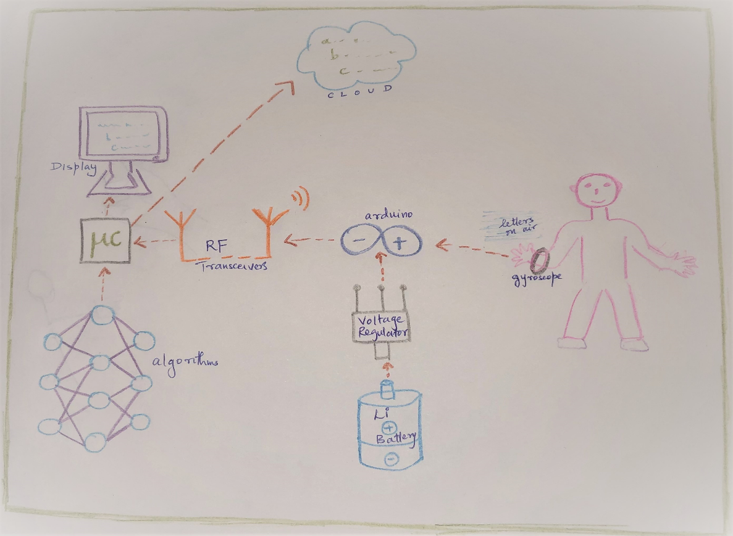

* + **Bill of Material**

|  |  |  |  |  |  |
| --- | --- | --- | --- | --- | --- |
| **Item Number** | **Part Number** | **Part Name** | **Description** | **Quantity** | **Remarks** |
| 1 | BBB-2820-102110420 | Beagle Bone Black | Low power open source development board which supports Debian | 1 | Used as master microcontroller device. |
| 2 | 031366 | Arduino uno | Open source microcontroller based on ATmega328P microcontroller equipped with Analog and Digital GPIOs | 1 | Used as a slave microcontroller device. |
| 3 | 6461060 | HC-12 433Mhz Rf Transmitter and Receiver | It’s a device which transmits and receives the data among the two devices. | 1 | Used as a transceiver between Arduino and beagle bone black. |
| 4 | 1428-1007-6 | Gyroscope | A sensor to measure the angular orientation and velocity. | 1 | Gyroscope sensor used to write letters in air |
| 5 | N702-F041 | Li-Ion Battery | A rechargeable battery for portable electronics | 1 | 3-cell Li-Ion Battery for power supply. |
| 6 | LCD-1602 | LCD Display | It's a flat panel 16x2 liquid crystal display | 1 | Used to display the letters. |
| 7 | PROWF-128266 | ESP8266 WIFI MODULE | It's a low-cost IEEE 802.11 Wi-Fi microchip with TCP/IP stack. | 1 | Used to push the data on to the cloud |
| 8 | LM2596T-12/NOPB | Voltage Regulator | Device used to maintain a constant regulated voltage | 2 | Voltage regulator to control and maintain the voltage levels at the devices connected |
| 9 | PCBBB-000120 | Bread Board |  | 1 | Used to develop a prototype |
| 10 | CONJU-032219 | Jumper wires |  | 20 | Used for connection purposes |
| 11 |  | Soldering kit and Digital Multimeter |  | 1 each | Used for miscellaneous purposes |

**Approaches during Edit-Test-Debug Cycle**

**Using a Target system:** Yes.

The primary components in a development environment are the host system, target system and the connections between the both.

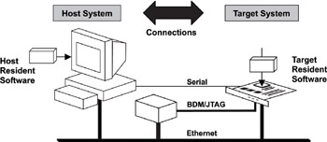

* Using a target system means developing, compiling, testing, and debugging on the host machine before translating it into the target device.
* In this project, we will be using Eclipse, Nano editor etc. in our host machine while having Beaglebone and Arduino as our targets.

**Using an emulator for target system**: No.

**Using Target Processor and ICE**: No.

**Using Simulator for Hardware**: No.

**Using IDE or prototyping Tool**: Yes.

* An IDE is an application which allows us to develop the software code.
* It usually consists of Editor, a compiler, linker, debugger, serial monitor, etc.
* We are using an Arduino IDE in our project to develop Arduino related source code.
* Eclipse IDE is an open-source IDE that supports c/c++, python etc.
* Prototyping is the process of building a model of a system. Prototyping tools define our ideas to make a design.
* Development boards are a critical resource during prototyping stages. These boards provide access to interfacing, connecting external modules for easy programming and debugging.
* Designing, building and testing the external sensor, communication, interfacing modules are an expansive task of embedded prototyping.
* The software tools like the IDE’s, machine learning algorithm, microcontrollers, slave devices, sensors and monitors form the prototyping tool to develop a model.

**References:**

* Vanditgajjar,Virajmavaniand Ayishagurnani .“Hand gesture real time paint tool-box” using machine learning. Conference on power, control, signals and instrumentation engineering (ICPCSI-2017).
* MarkusModzelewski and Esteban BaytroKaiser. "Hand Gesture Recognition Interface for Visually Impaired and Blind People", International Conference on Computer and Information Science (2012).
* Electronics Hub (2016, October 29). Arduino and RF transmitter receiver module. Retrieved from <https://www.electronicshub.org/arduino-rf-transmitter-receiver-module>
* Instructable circuits (n.d). Connecting Arduino Wi-Fi to the cloud using ESP8266. Retrieved from <https://www.instructables.com/id/Connecting-Arduino-WiFi-to-the-Cloud-Using-ESP8266>
* Admin. (2015, June 12). Retrieved September 25, 2020, from <https://toptechboy.com/beaglebone-black-gps-lesson-1-hooking-up-the-adafruit-ultimate-gps/>
* Downloading GCC. (n.d.). Retrieved September 27, 2020, from <https://gcc.gnu.org/install/download.html>
* Mouser Electronics(n.d.). 433 MHZ RF modules. Retrieved September 27, 2020, from <https://www.mouser.in/Embedded-Solutions/Wireless-RF-Modules/RF-Modules/_/N-6sri4?P=1z0wh7m>
* Battery university(n.d.). Retrieved September 27, 2020, from <https://batteryuniversity.com/learn/archive/is_lithium_ion_the_ideal_battery>
* I2C Info – I2C Bus, Interface and Protocol. (n.d.). Retrieved October 04, 2020, from <https://i2c.info/>
* Elprocus(2014, October 01). Serial Peripheral Interface - SPI Communication Protocol. Retrieved October 04, 2020, from <https://www.elprocus.com/serial-peripheral-interface-spi-communication-protocol/>
* The Standard for IoT Messaging. (n.d.). Retrieved October 04, 2020, from <https://mqtt.org/>
* Zain(2020, July 03). Introduction to ESP8266. Retrieved October 04, 2020, from <https://www.theengineeringprojects.com/2018/08/introduction-to-esp8266.html>
* MISRA: Software Development Guidelines For C Programming Language. (2019, December 16). Retrieved October 04, 2020, from <https://www.kiuwan.com/blog/misra-software-development-guidelines-c-programming-language/>
* Abraham, D. (2018, May 01). A Basic Introduction to Python Programming Language – Part 1. Retrieved October 04, 2020, from <https://www.codeproject.com/Articles/1240791/A-basic-introduction-to-python-programming-languag>
* Powertech(n.d.). Retrieved October 04, 2020, from <https://www.bing.com/search?q=power+efficiceny+of+lithuim+battery>
* Digi key(n.d.). Retrieved October 05,2020 from <https://www.digikey.ca/en/products/detail/beagleboard-by-seeed-studio/102110420/12719590>
* Amazon(n.d.). SMAKN® 433Mhz Rf Transmitter and Receiver Link Kit for Arduino/Arm/McU. Retrieved October 05,2020 from <https://www.amazon.ca/SMAKN%C2%AE-433Mhz-Transmitter-Receiver-Arduino/dp/B00M2CUALS>
* Creatron INC(n.d.). ESP8266 Wi-Fi Development Board. Retrieved October 05,2020 from <https://www.creatroninc.com/product/esp8266-wifi-development-board-2/>
* <https://www.youtube.com/watch?v=OjTNS2ZKqRc&feature=share>
* <https://www.youtube.com/watch?v=ImL3Hi1yVYg>
* J. E. Tardy. Host/target approach to embedded system development is becoming obsolete. Retrieved October 08, 2020, from <https://dl.acm.org/doi/10.1145/58418.58421>
* What is an IDE? (n.d.). Retrieved October 08, 2020, from <https://www.redhat.com/en/topics/middleware/what-is-ide>
* Yao.C(n.d.). Real time concepts for embedded system. Retrieved October 08,2020 from <https://www.globalspec.com/reference/25390/203279/chapter-2-basics-of-developing-for-embedded-systems>
* Embedded lab (2010, December 21). Regulated power supply for embedded system. Retrieved October 09,2020 from <http://embedded-lab.com/blog/regulated-power-supply-for-embedded-systems/>
* Electronics Notes(n.d.). What is a DMM. Retrieved October 09,2020 from <https://www.electronics-notes.com/articles/test-methods/meters/dmm-digital-multimeter.php>
* Twi(n.d.). What is soldering? Retrieved October 09,2020 from <https://www.twi-global.com/technical-knowledge/faqs/what-is-soldering>
* Wiring(n.d.). What is a jumper wire? Retrieved October 09,2020 from <http://wiring.org.co/learning/tutorials/breadboard/>

**Instructor’s Remarks:**